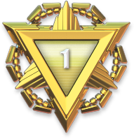

**UZAIR**

**HUSSNAIN**

This award is a symbol of the dedication and commitment you have shown in learning and promoting **Digital Literacy**. Your efforts in understanding and utilizing digital tools effectively have contributed to a smarter and more connected world. This certificate serves as motivation and recognition of your hard work and achievements in the field of digital education.

**MUZAMMAL HUSSAIN**

**This Certificate Is Presented To**

OF APPRECIATION

**CERTIFICATE**